***Mac Users***

**To Install R**

Open an internet browser and go to www.r-project.org.

Click the "download R" link in the middle of the page under "Getting Started."

Select a CRAN location (a mirror site) and click the corresponding link.

Click on the "Download R for (Mac) OS X" link at the top of the page.

Click on the file containing the latest version of R under "Files."

Save the .pkg file, double-click it to open, and follow the installation instructions.

Now that R is installed, you need to download and install RStudio.

**To Install RStudio**

Go to www.rstudio.com and click on the "Download RStudio" button.

Click on "Download RStudio Desktop."

Click on the version recommended for your system, or the latest Mac version, save the .dmg file on your computer, double-click it to open, and then drag and drop it to your applications folder.

*Windows Users*

To Install R:

Open an internet browser and go to www.r-project.org.

Click the "download R" link in the middle of the page under "Getting Started."

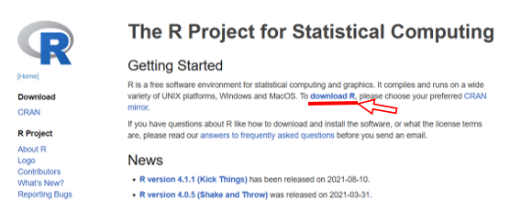

Select a CRAN location (a mirror site) and click the corresponding link.

Click on the "Download R for Windows" link at the top of the page.

Click on the "install R for the first time" link at the top of the page.

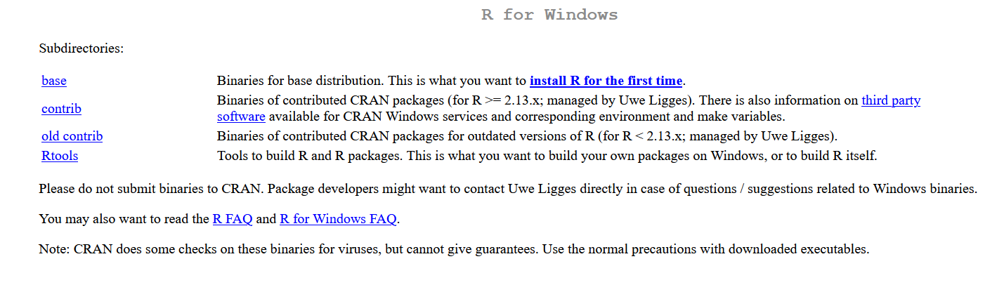

Click "Download R for Windows" and save the executable file somewhere on your computer. Run the .exe file and follow the installation instructions.

Now that R is installed, you need to download and install RStudio.

To Install RStudio

Go to www.rstudio.com and click on the "Download RStudio" button.

Click on "Download RStudio Desktop."

Click on the version recommended for your system, or the latest Windows version, and save the executable file. Run the .exe file and follow the installation instructions.

